GOOD NEWS FOR YOU
OCTOBER 9-13
FIELD TRIP TO COLEMAN ON THURSDAY
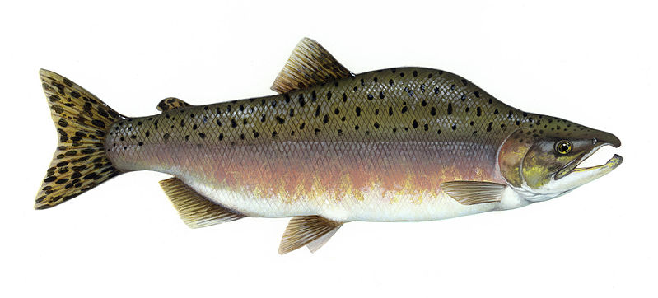

Bible Verse Psalm 100:5 “For the Lord is good, His mercy is everlasting, and His truth endureth to all generations.”
Show and Tell Something that begins with “s.”

October 12, 2017 8:45-2:00
Field trip day! K-1 will be joining the rest of the elementary students for a day at Coleman Fish Hatchery. You are welcome to take your child home after the field trip. Please pack a sack lunch and wear your special salmon t-shirt we made. It is going to be a great day!

Thank you if you had a chance to participate in Drive 4ur School!
We have wonderful families here at our school and we appreciate all of your encouragement and support.
**Special thanks to a family in our class for the new water dispensers in our classrooms. The water tastes so good!
**Go Cross Country Runners! We wish you a great run this Friday!

Kindergarten
Monday Please review the work in your folder, and practice your verse. Listen to an adult read to you. After the story, look at the words in the book. Can you find any that have the same letters as your name?
Tuesday Count forward and backward. Practice writing your numbers 1-20. We will work on number formation of 7, 8, 9, and 10 this week; along with our teens!
Pack your library book for tomorrow, please.
Wednesday No homework!
Thursday Listen to another story. Don’t forget to fill in the reading log. 12 entries earn a prize!! Practice your verse.
Friday Say your verse today. Psalm 100:5
Show and Tell – “s”

Concepts this Week
*Telling the truth
*ABC’s – what comes next?
*Counting, missing numbers, pennies, teens, one more, one less,
same, graphing numbers, greater, number formation.
*Chapter Check Up in Math this week.
FIRST GRADE

SPELLING WORDS
map clap flap hum sum drum class glass grass of

Monday Review the work in your folder, practice Psalm 100:5. Read in your reader; record the number of pages, please.
Tuesday Spelling practice, turn in your words. Read your reader, and review the verse.
Make sure you have your library book for tomorrow.
Wednesday No homework, field trip tomorrow!
Thursday Field Trip – lunch, water
Read in your reader, pack Show and Tell – “s”
Review your spelling words.
Friday Spelling test today

**New math vocab this week: meterstick, centimeters, decimeters.
**Suffixes – er, est Special Sounds – sc, sk, sm, sp, bl, cl, fl, gl,
pl

