Kindergarten Newsletter
April 18-21, 2017
Living Our Faith by Showing Mercy

Star of the Week Rhyane
Bible Verse Psalm 75:1 “Unto Thee, O God, do we give thanks.”
Show and Tell Your choice!
This Week
Monday No School
Tuesday Please review the papers in the folder. Assessments are included, watch for areas that need extra practice. Thank you!
Wednesday Practice your verse. We worked on it before vacation, but this week I will have you recite it on Friday.
Thursday Read for the reading log. Are you ready for another reader? Remember, when two vowels go walking, the first one does the talking, and the second one is silent!
Friday Show and Tell! P.E. today. Please wear appropriate shoes. Thanks!
Turn in all homework.

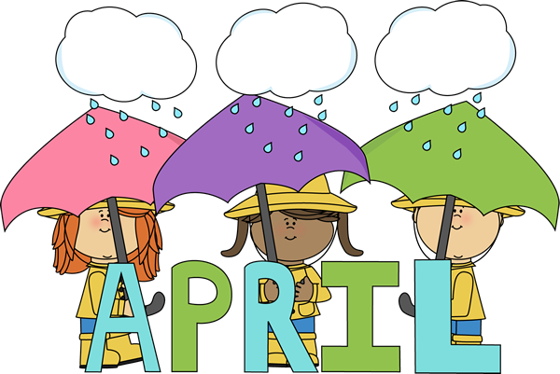
Concepts this Week
Bible 10 Lepers, one returns to give thanks to Jesus. Review Easter lessons.
Reading Practice special sounds, reading through individualized readers, write words from dictation, learn ch in church, ar in stars, or in morning.
Numbers Add and subtract, coin review, ordinal numbers – 1st-10th place. Telling time, between numbers, count by 2’s.
Social Studies Children from Peru
Science Seasons
COMING EVENTS
April 22, 2017 Auction on Saturday! Everyone welcome!
May 2, 2017 Field Trip – Whiskeytown Environmental Camp. Leaving in morning, return early afternoon.
May 5, 2017 Cinco de Mayo, Insect Project due today
May 11, 2017 Open House – 7 p.m.

